**CableBuilder_v3_3 Instructions**

CableBuilder will generate a cable curve that connects a selection of pylons, starting from a manually set origin pylon and continuously progressing to the next closest pylon within the selection. The origin pylon’s HGT, CAT, and CTUU are applied to the generated cable.

**Step 1:** Install the add-in located here:  
\\birmfs01\birmbackup01\Toolbars\Cable_BuilderFilename: CableBuilder_v3_3.esriaddin  
  
To uninstall a previous version: In ArcMap, go to Customize > Add-In Manager, select the old version and then Delete this Add-In

**Step 2:** Open ArcMap and either **[**use a utility template**]** or **[**load UtilityInfrastructurePoints and UtilityInfrastructureCurves into a blank MXD. Definition query the points to only include PYLON_P, POWER_SUBSTATION_P, and ELECTRIC_POWER_STATION_P. Definition query the curves to only include CABLE_C**]**

**Step 3:** Start an editing session. (Note: If the working database is an SDE, please review the yellow highlighted section on page 3 before running the tool)

**Step 4:** If the toolbar is not visible, it can be turned on with Customize > Toolbars > Cable Builder



**Step 5:** The Buttons™ - Use them in the following order

(**Set Cable Layer**) In the Table of Contents, left-click the layer name containing cables to highlight it and then click this button. You only need to do this once at the beginning of your ArcMap session

If the layer is highlighted like this, you are ready to click Set Cable Layer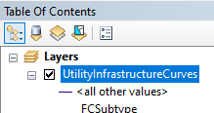

(**Set First Pylon**) Select the starting pylon for the cable. The cable will use this pylon’s height, cable type, and CTUU. The starting point *can* be a substation or power station, but it should ideally be a pylon to ensure there are populated attributes to transfer into the cable.

(**Build Cable**) Select each additional pylon the cable will connect with and then click this button to create the cable.

Here are annotated examples of the tool in use:  
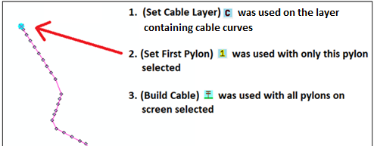

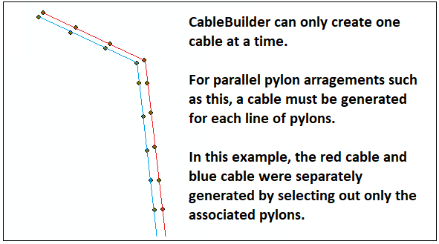

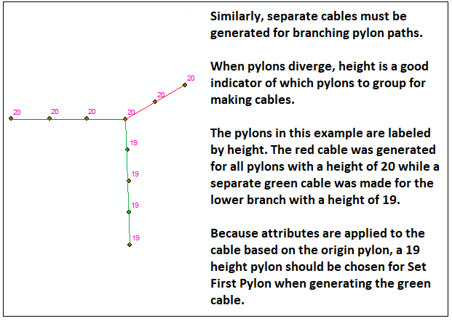

Extra notes and tips:   
-**This tool requires that only pylons, substations, and/or power stations are selected for Set First Pylon and Build Cable**

**- The layer containing the pylon for Set First Pylon cannot have unusual characters in its name in the Table of Contents:** This is most commonly a front slash or apostrophe (Ex: “Cables/Pylons”). It also cannot have an empty space at the end (Ex: “Cables “). There are probably additional illegal characters out there.  
  
-**Using an interactive selection method like Select by Lasso with ‘Add to Selection Only’ is a quick and action-packed way to round up pylons**. The interactive selection method can be changed like so:   
Selection (along the top bar of Arcmap) > Interactive Selection Method > Add to Selection

**-Setting hotkeys for (Set First Pylon), (Build Cable), and (Select by Lasso) will speed up the process.** This can be done in Customize > Customize Mode > Keyboard (button at bottom of menu)

-If a cable generated incorrectly in a complicated area, you can either: split out, delete, and manually remake the bad section of cable or repair it with a reshape. To reshape, begin reshaping from the pylon where the bad section begins and then click through the pylons that follow in the order that the cable should have been drawn.  
**\*\*\*Extremely important usage note for SDE\*\*\***

-**In an SDE, Undo/Redo is unreliable with anything this tool does:** Undo/redo will only work with this tool if a manual edit was made immediately before the tool was run (such as creating a feature, adding a vertex, etc.). In most cases, it will be best to just delete the generated cable as a way of manually reversing the tool’s action. The Undo/Redo history is usually cleared each time the tool is used as well. (still investigating this)  
**\*\*\*Note for Finishing Team\*\*\*** The attributes of cables generated by this tool default to <null> rather than the proper schema default. To correct this, run a selection of generated cables through the tool Calculate Default Values.   
  
**Note:** The process below is best done in a local database and will run much faster outside of an edit session, but there will be no way to undo the changes. **However, if you are following this workflow for an SDE, be certain you are in an edit session in all cases.**  
To repair the null values:  
-Load UtilityInfrastructureCrv into a template   
-Open Select by Attributes (Selection > Select by Attributes)  
-Run this query to return all cables made by the tool:   
**fcsubtype = 100199 AND dev is NULL**  
**-**Use Search  to locate and then open the tool Calculate Default Values   
-With the cables still selected, drag UtilityInfrastructureCurves from the Table of Contents to the tool’s input window, click OK and wait for the tool to complete  
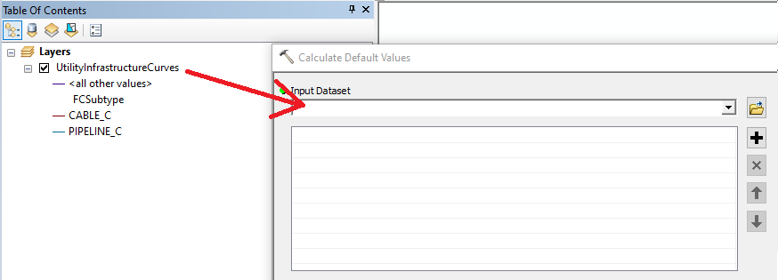

--------------------  
Feel free contact me with any questions, feedback, or bugs encountered.   
Tyler Johnson in Teams or tmjohnson@wiser.team